CHAPTER 8: Forces, energy and motion
Worksheet 8.6

Newton’s Second Law
Science Quest 10: pages 316–17
Answers
1. State Newton’s Second Law of Motion.
The acceleration of a body is directly proportional to the net force and inversely proportional to its mass.

2. Use the formula: F = ma to complete the following table
Force (F) (newtons) | Mass (m) | Acceleration (a)
100 | 40 kg | 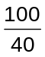 = 2.5 m/s²
2 | 200 g | 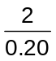 = 10 m/s²
70 | 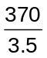 = 20 kg | 3.5 m/s²
100 | 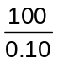 = 1000 kg | 10 cm/s²
3. Consider the forces acting on a body of mass 40 kg resting on a frictionless surface.
 | 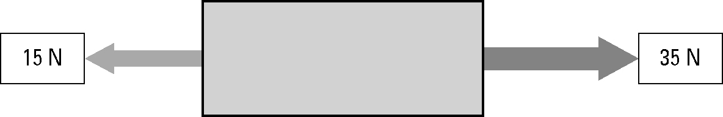 | (a) Calculate the net force acting  on the body.  F = 35 − 15 = 20 N
(b) Calculate the acceleration of the body.
a = 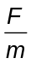 = 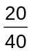 = 0.5 m/s²

4. The photo shows a drag car coming to a stop at the end of a race.
© GettyImages/Stone/George Lepp | 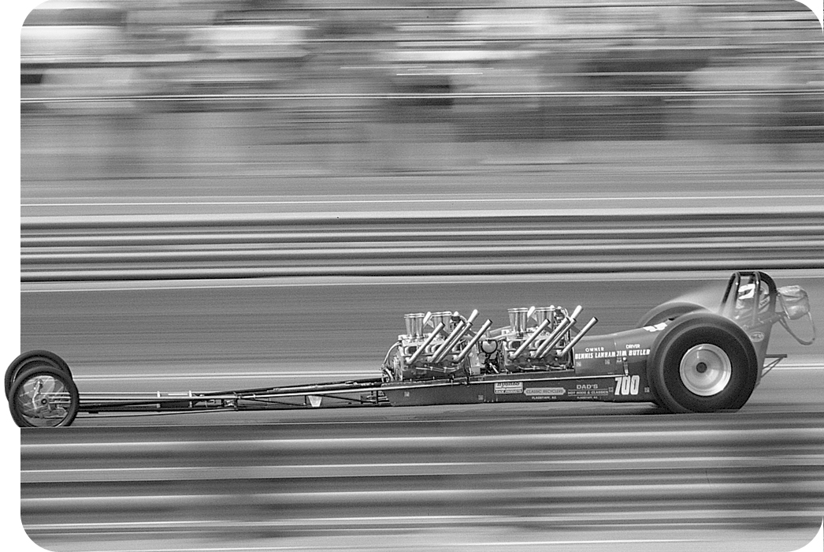
(a) To come to a complete stop the drag car negatively accelerates. Identify another term for ‘negative acceleration’. ...................................................................
Deceleration
(b) Identify the force that brings the drag car to a stop. .....................................................................
Friction

